Setup minikube at your local and explore creating namespaces

Namespace Created :

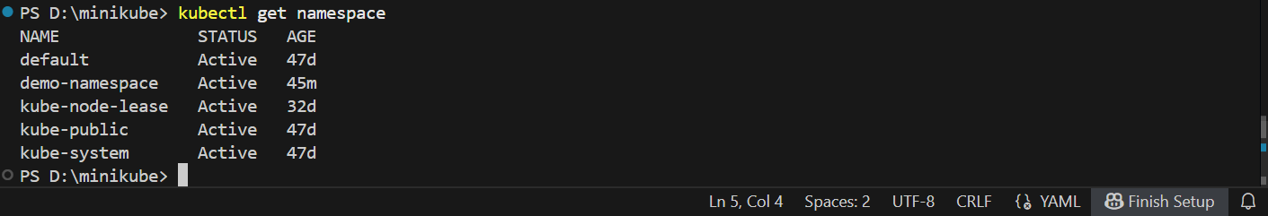

Writing Nginx Yaml file for testing

Running the yaml file and deploying

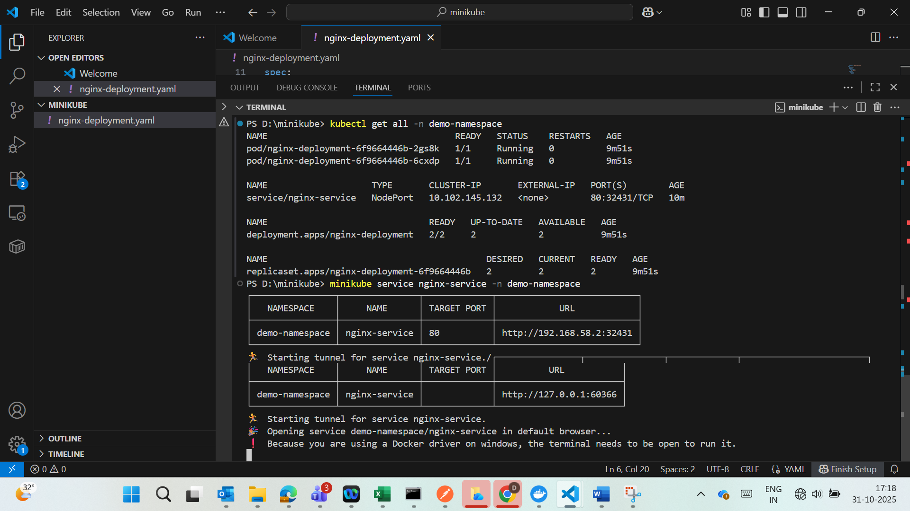

Output:

